Phase 4 LCSF: Payment Process Guidance Notes
The purpose of this guidance note is to present a brief explanation for the Phase 4 Low Carbon Skills Fund (LCSF) payment process. We recommend reading the entire document before proceeding with the payment steps. The document contents are:
- Payment Timeline
- Forecast Payment Schedule
- Documentation Requirements and Links
- Avoiding common delays and issues
- Case Study

Payment Timeline
Dark boxes below refer to a client action, whilst light blue means a Salix action. Grey boxes provide an example of the dates required for November payments. These dates match the case study provided on page 3.
Please note, the first possible payment month is September 2023, for which forecasts need to be received before 3rd August 2023. This allows time for Salix to draw down funds from government.
After receiving your CRM logins, you should have submitted an initial forecast online. This will need to be reconfirmed alongside the second Monitoring Report deadline (9th November 2023).
Salix Provisional Forecast sent to DESNZ
Salix internal due diligence
Evidence approved.
Further evidence required and claimed timelines missed.
Evidence Approved.
Further evidence still required.
Confirm Payment Profile with Salix
Payment Forecast – Complete the Schedule 3 link which was shared via email
By Wednesday 4th October
Claim submitted by payment request submission deadline in the Schedule 3
Send to Salix evidence, Schedule 5, and SoE with value matching forecast value
By Wednesday 18th October

Friday of following month
Salix sends Claim to DESNZ
By Friday 10th November
Expected payment dates in Schedule 3
Receive Payment
By Wednesday 15th November
Following month
Send to Salix delayed/updated evidence.

By Wednesday 22nd November

Forecast Payment Schedule
Payment month | Payment profile to be confirmed with Salix | Payment request submission deadline | Date of expected payment
September 2023 | 03/08/2023 | 23/08/2023 | 20/09/2023
October 2023 | 05/09/2023 | 20/09/2023 | 18/10/2023
November 2023 | 04/10/2023 | 18/10/2023 | 15/11/2023
December 2023 | 04/11/2023 | 22/11/2023 | 20/12/2023
January 2024 | 05/12/2023 | 03/01/2024 | 24/01/2024
February 2024 | 04/01/2023 | 24/01/2024 | 21/02/2024
March 2024 | 05/02/2023 | 21/02/2024 | 20/03/2024
April 2024 | TBC | 20/03/2024 | TBC
May 2024 | TBC | 12/04/2024 | TBC

Documentation Requirements and Links
Required Documents for Payment:
- Sch. 5 Payment Request as a signed PDF; Note, this figure should match the payment value and month cited in an updated Schedule 3. Schedule 5 Downloadable Link
- Evidence of need; Invoices - Please confirm with your contractor when these will be available as Salix are unable to process claims without full invoice evidence supporting the value requested in Schedule 3 & 5.
- Signed Statement of Expenditure (SoE); Please return as an Excel and signed PDF document along with the documents mentioned above. Statement of Expenditure (SoE) Downloadable Link

Avoiding common delays and issues
Here we highlight some of the most common ways in which payments have been delayed, and the best solutions to these challenges:
FAQ:1 - Purchase orders: Can I send a purchase order instead of an invoice as evidence of expenditure?
A: Salix are unable to accept purchase orders instead of invoices. We accept them as support for invoices and they may be requested to support the submission of multiple invoices. However, please ensure you are only forecasting values you know will be supported by invoices.
FAQ:2 – Invoice format: Can invoices be sent in word/email/screenshot format?
A: Salix are unable to accept any unofficial invoice. Please ask contractors to supply invoices in PDF or scanned, signed hard copies. Please note, the invoice should reference Phase 4 LCSF and the purpose of the work with respect to the heat decarbonisation plan.

Case Study
This section provides an example of a client that is making a payment request, and the actions that should be taken to receive this payment from Salix.
Step 1: Confirm with the contractor the date of invoice and the amount on the invoice and when this will have gone through your internal validation processes.
Step 2: Inform Salix by Thursday 3rd August forecast for the grant drawdown value(s) and month. Example 1 indicates how to complete Schedule 3 with no interim payment on receipt of final invoices. One interim payment is optional and can be requested by completing Schedule 3 as demonstrated in Example 2.
(Example 1)
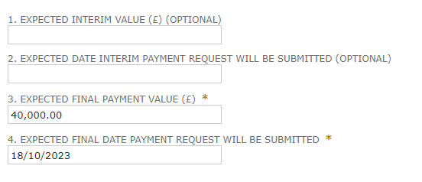
(Example 2)
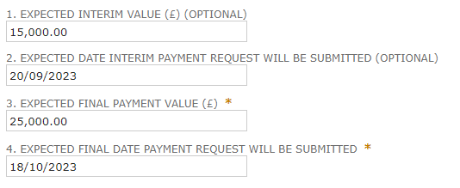
Step 3: Collate evidence (invoices) before the month of payment (in Example 1, the invoices should be provided by 18/10/2023 for a November payment and fill in the Statement of Expenditure accordingly. The earlier this can be provided the more time Salix will have to come back with any queries increasing the likelihood of a successful payment within the payment window. Funds are received from DESNZ once per month so if the payment window is missed, Salix will be unable to pay clients until the following month.
Step 4: Send over invoices, Schedule 5, and Statement of Expenditure when all evidence has been received from consultant/contractor. Ensure figures match the requested drawdown.
Step 5: If changes are required, please correct Statement of Expenditures/Schedules and provide further evidence to Salix.
Step 6: Receive payment before the end of month.

