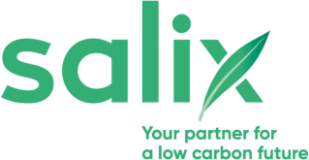
Phase 4 Low Carbon Skills Fund: Contract Award Information Form

Organisation name:
Project title:
Submission ID:
Grant value awarded:

Purpose of the Contract Award Information Form
This form has been provided at the project delivery stage and enables your organisation to confirm certain details as part of the grant process, to ensure that we can reallocate funding, if appropriate. This document aims to act as evidence of a contract being awarded to a consultant or contractor. This should include the final post-procurement cost for the delivery of the LCSF4 work(s). Salix will not pay VAT and it should not be included as part of the grant unless your organisation cannot reclaim VAT. This form can be completed by the Main Contact but must be signed by the designated Authorising Official.

- I confirm that the final post-procurement cost for producing the LCSF4 work(s) is:
£ Gross (includes VAT)

£ Net (excludes VAT)

Note: Salix will not pay VAT and it should not be included as part of the grant unless your organisation cannot reclaim VAT.

- Is your organisation able to reclaim VAT:

Yes ☐ No ☐

If you are only able to reclaim some of the VAT, please comment on the amount and confirm full new project value in the space below:

- Please confirm the name of the consultant/contractor that the contract has been awarded to:

- Please provide the start and expected completion dates for the project that was agreed with the consultant/contractor:

Start date:
Note: The start date refers to the date that the pre-onsite work begins.

Expected completion date:

- Please provide a description of the work that has been contracted, relating to the grant scheme:

As the designated Authorising Official, I confirm that the above information is accurate.

Authorising Official Name:
Authorising Official Title:

Authorising Official Signature:
Date:

For and on behalf of

